From The Top

User Guide

by

Joe Stainke

In partial fulfilment of the requirements for the degree of

MSc in

Software Development



Department of

Computer and Information Sciences

August, 2022

Screen 1: Welcome

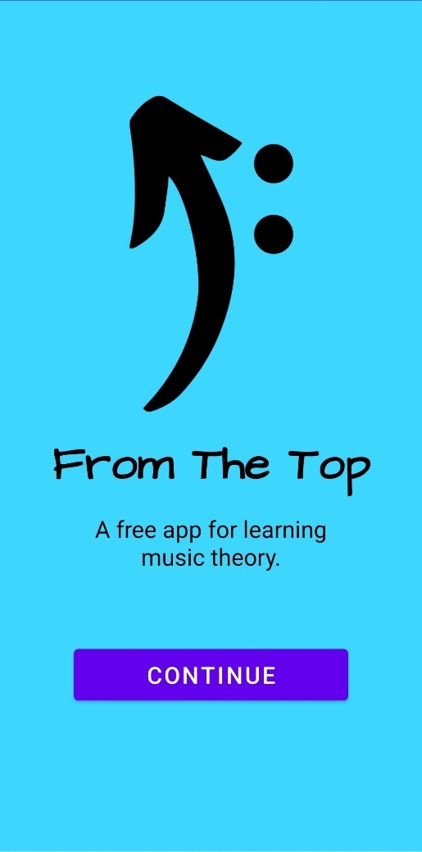Upon opening the app, you will land on the Welcome screen. Press the Continue button to progress.

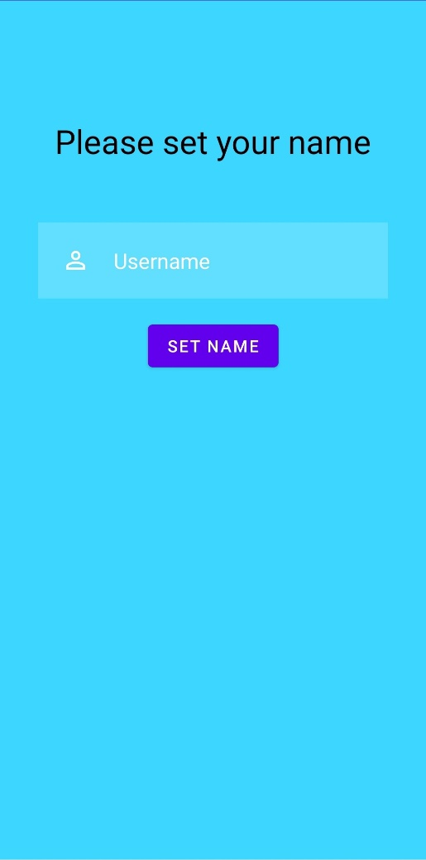Screen 2a: Set Name

Press inside the text box, enter your name and press the Set Name button to confirm. A Continue button will then appear.

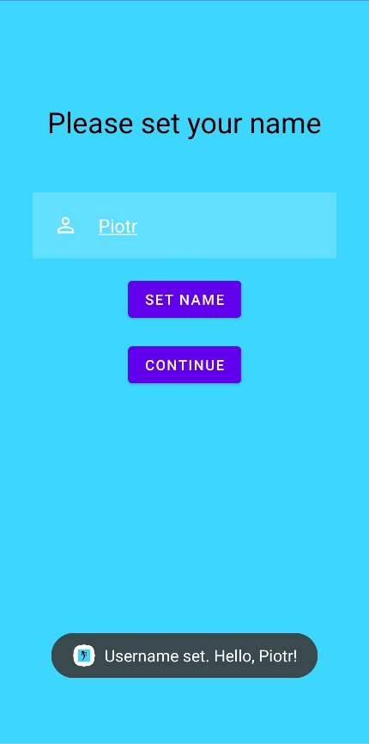Screen 2b: Set Name

If you are unhappy with what you have entered, you are able to change your name and set it again. If you are happy, press the Continue button to progress.

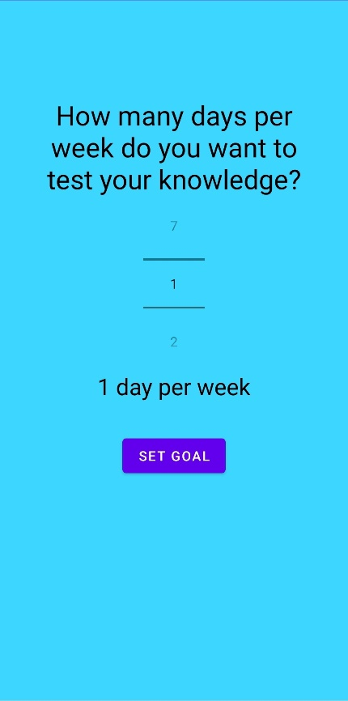Screen 3a: Set Goal

*From The Top* allows you to set a goal of how many days per week you want to take a quiz. Use the scroller to select a number, then press the Confirm button. A Continue button will then appear.

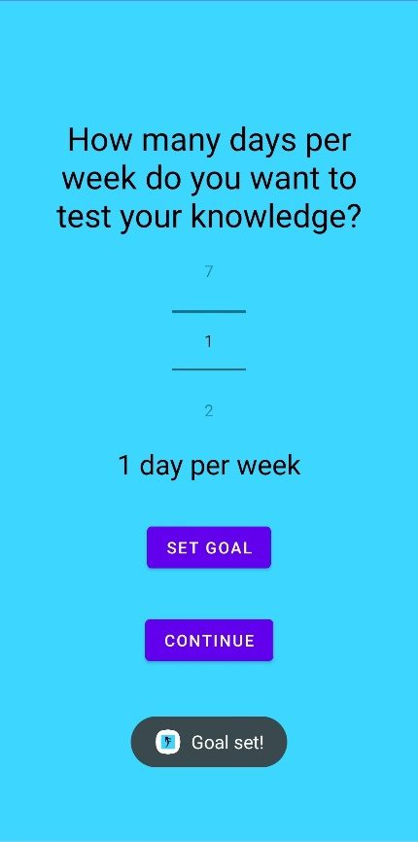Screen 3b: Set Goal

If you are unhappy with what you have entered, you are able to change the number and set it again. If you are happy, press the Continue button to progress.

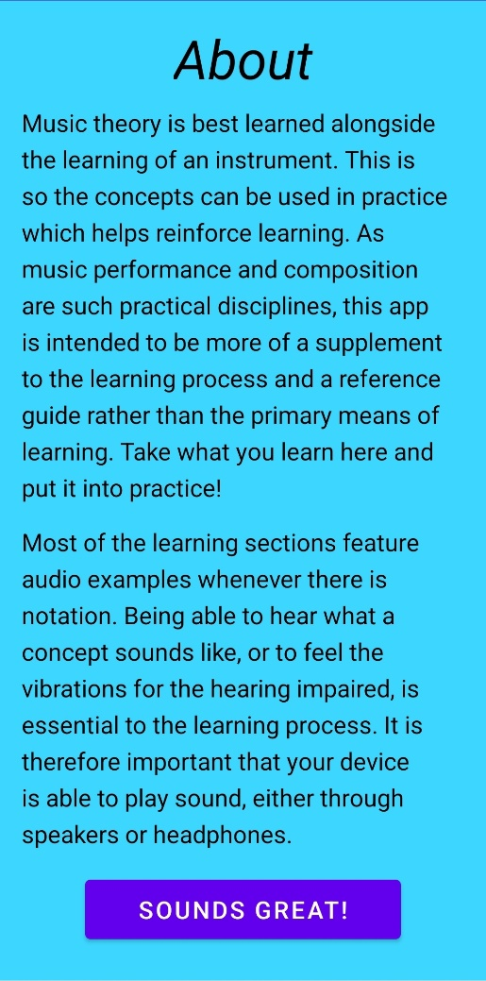Screen 4: About

Read the content on this page to learn more about how to best engage with *From The Top*. Once you are finished, press the Sounds Great button to progress.

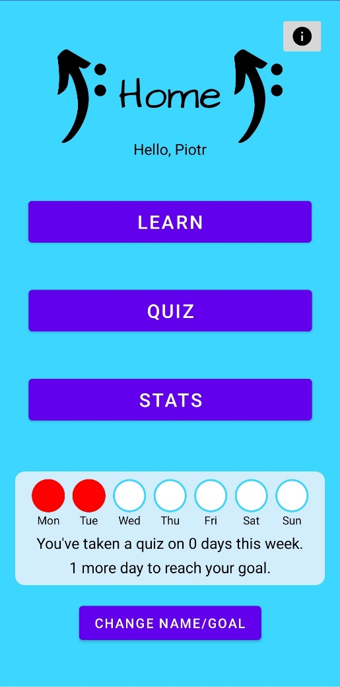Screen 5: Home

You will then arrive at the Home screen. From here, you can access all the features of *From The Top*.

The section near the bottom shows current progress towards your weekly goal. This guide was created on a Wednesday, so Monday and Tuesday are marked as red.

Pressing the information button in the top right corner will take you to the About screen again.

Pressing the Change Name/Goal button at the bottom will allow you to change your name or goal at any point.

Press the Learn button to progress.

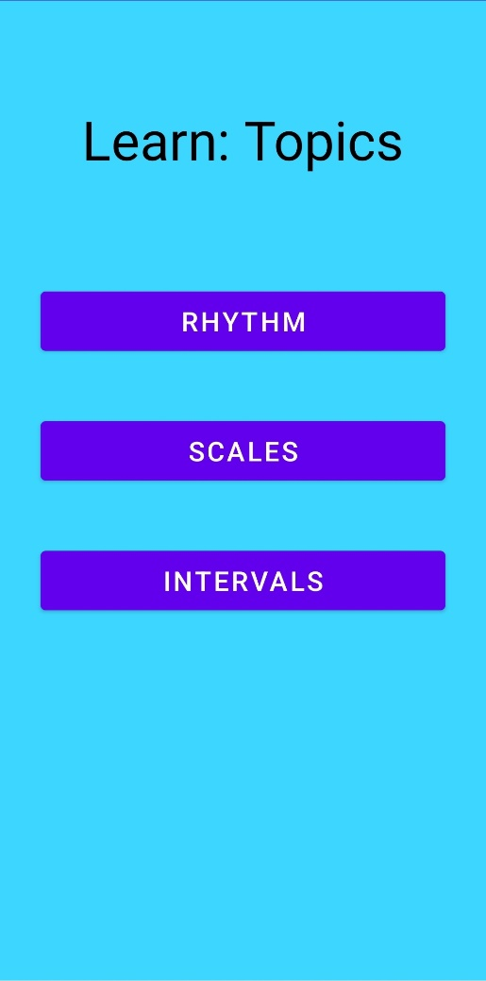Screen 6: Topic Select

On this screen is a list of music theory topics that you can choose to learn about. In this guide, we will focus on scales. Press the Scales button to progress.

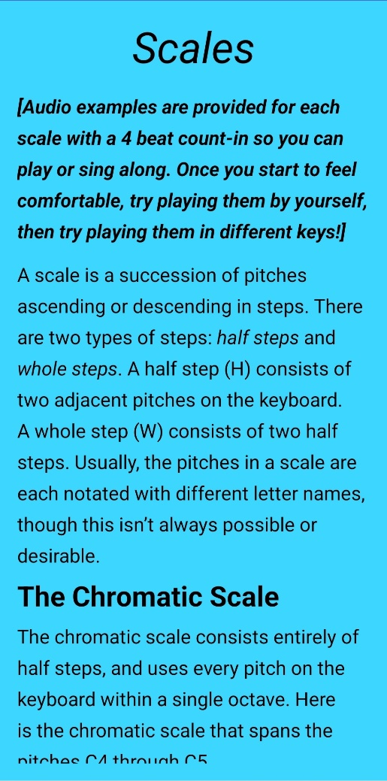Screen 7a: Learn Scales

These are the learning materials for the scales topic. The learning screens require you to scroll through them.

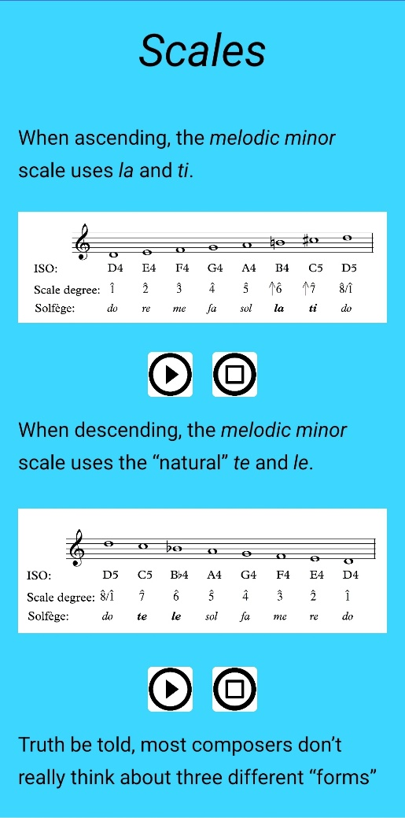Screen 7b: Learn Scales

Each learning screen includes audio to go along with the examples. Press the Play buttons to play them, and the Stop buttons to stop them. You will notice that starting one sound while another is playing will stop the other sound. Continue scrolling to the bottom.

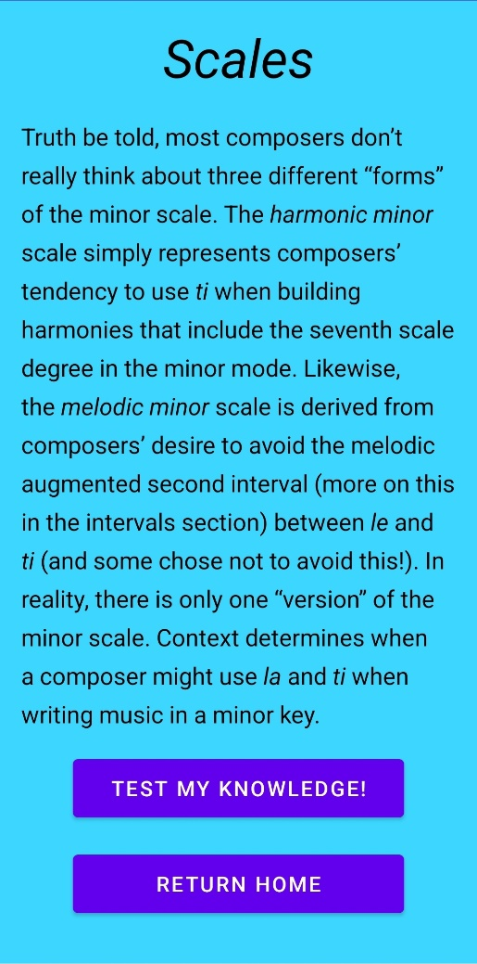Screen 7c: Learn Scales

At the end of each learning screen, you will be given the option to either take a quiz on that topic by pressing the Test My Knowledge button or return home by pressing the Return Home button. To see the alternative route to taking a quiz, press the Return Home button, then from the Home screen, press the Quiz button.

\*Make sure to leave the page by pressing one of the buttons at the bottom instead of your device’s built-in back button, otherwise course progress will not be saved.

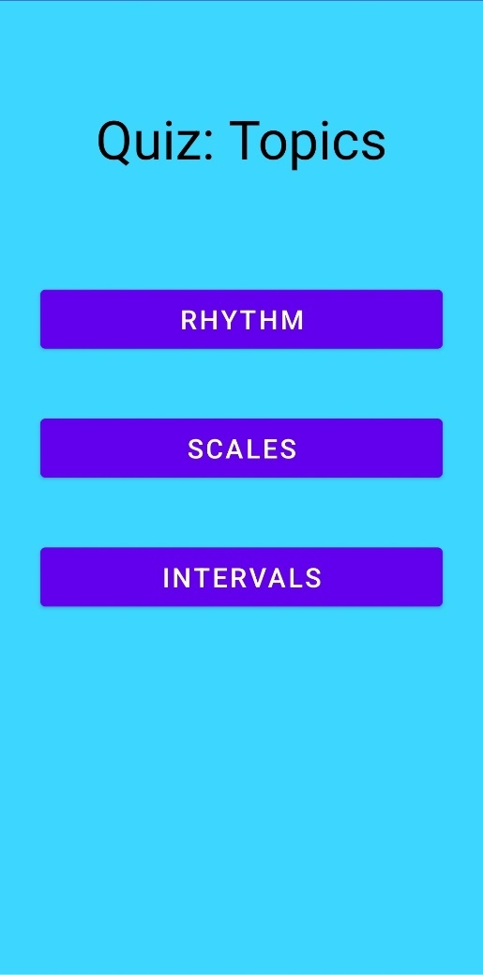Screen 8: Quiz Select

On this screen, you can choose which topic to take a quiz on. Press the Scales button.

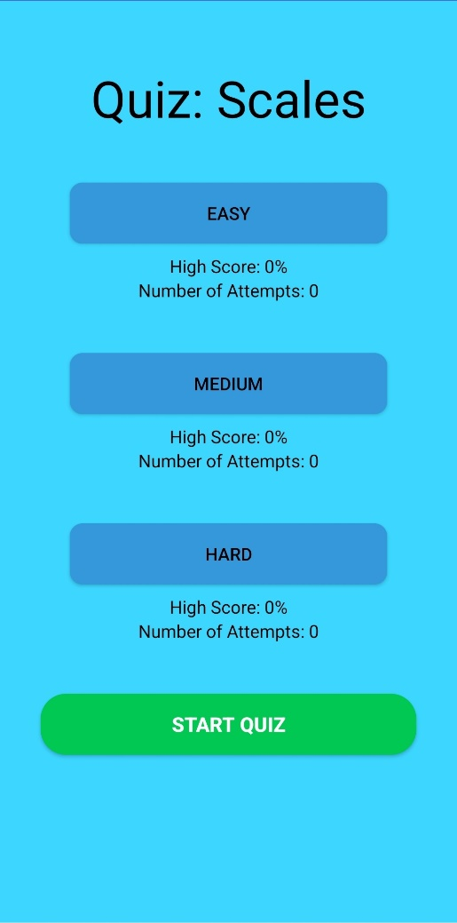Screen 9a: Quiz Select

Here you can select the quiz difficulty for the topic you have selected. Press the Easy button.

Screen 9b: Quiz Select

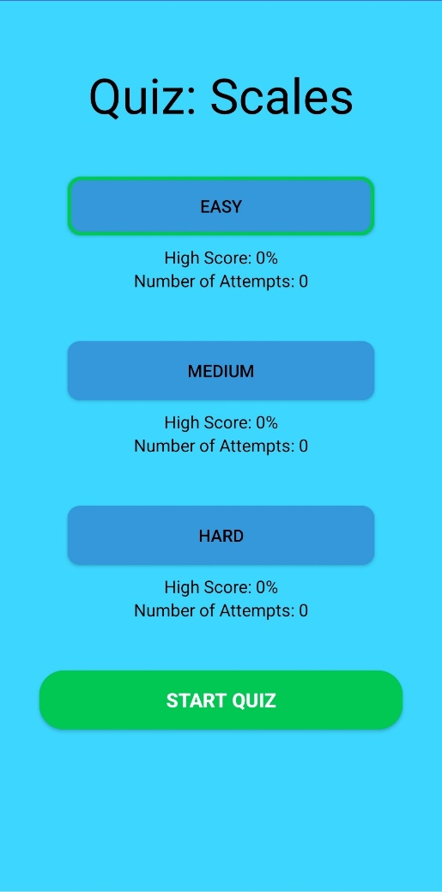A border will appear around the selected difficulty. Press the Start Quiz button to start the quiz.

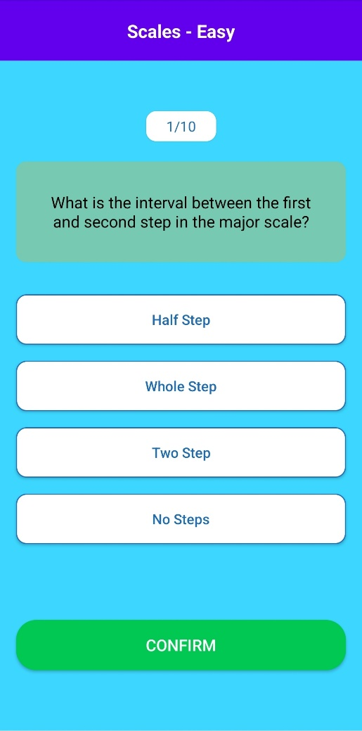Screen 10a: Quiz

Here is the quiz screen. The questions are shuffled each time a quiz is started, so the question you see will likely differ from the one shown. Select an answer from one of the options by pressing it.

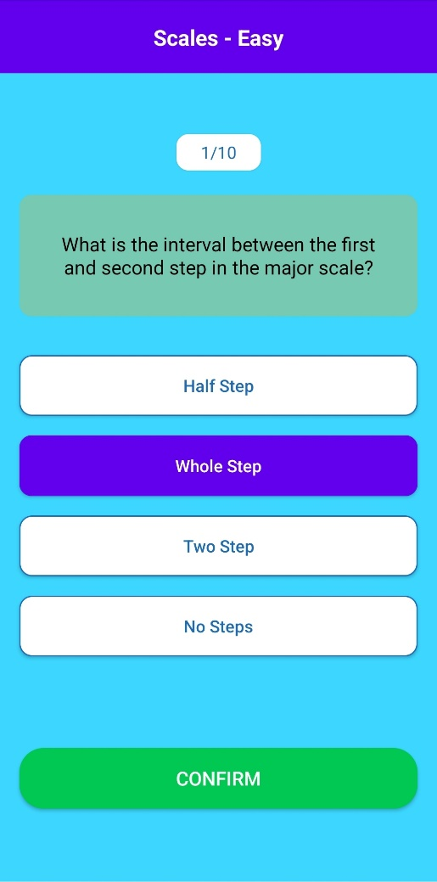Screen 10b: Quiz

The answer you have selected will turn blue. Press the Confirm button once you are happy with your selection.

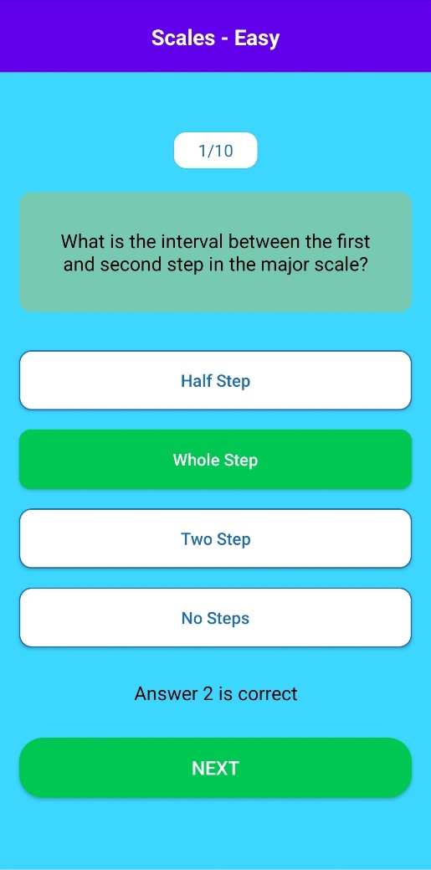Screen 10c: Quiz

If the answer you have submitted is correct, the option will turn green. Text will appear underneath the options as a secondary way of showing this information. Press the Next button.

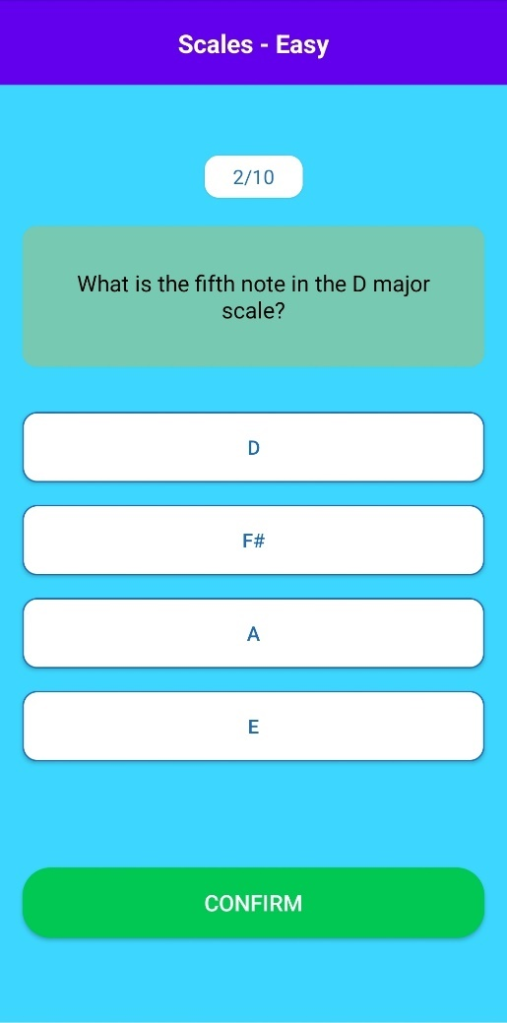Screen 10d: Quiz

Select an answer as you did for the first question.

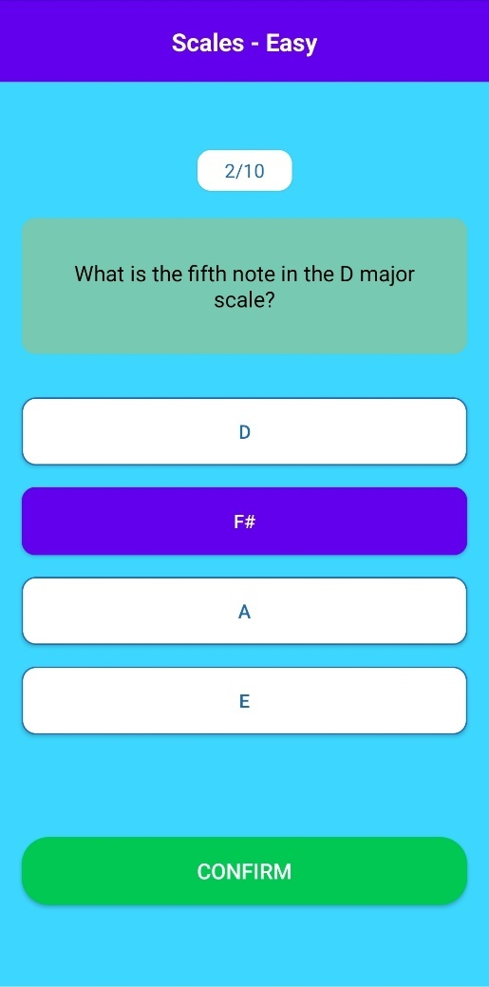Screen 10e: Quiz

After selecting an answer, press confirm.

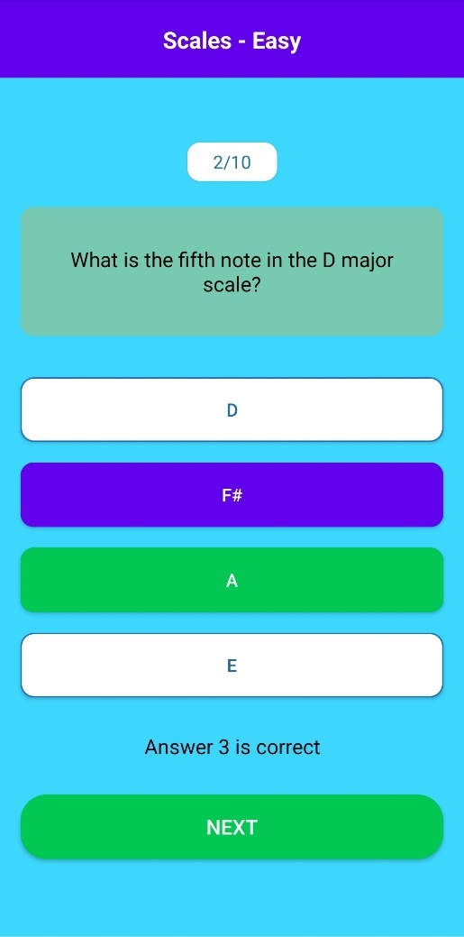Screen 10f: Quiz

If the wrong answer is submitted, as it has been here, the correct answer will turn green and the submitted answer will remain blue. Press the Next button to progress. Repeat these steps until you have answered the final question.

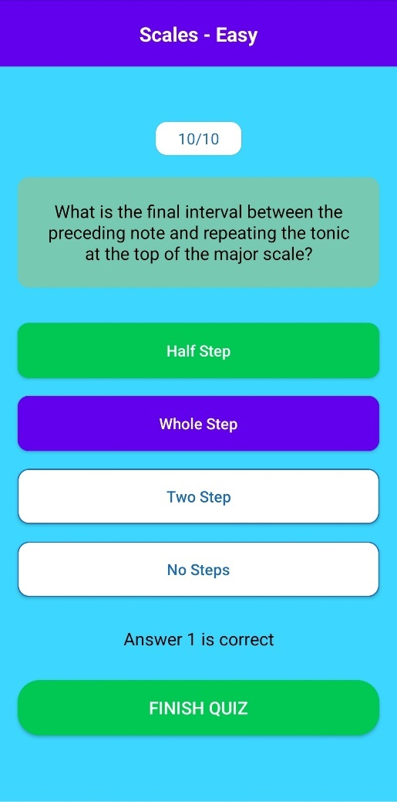Screen 10g: Quiz

Upon answering the final question, the button at the bottom will read “Finish Quiz” instead of “Next”. Press the button to finish the quiz.

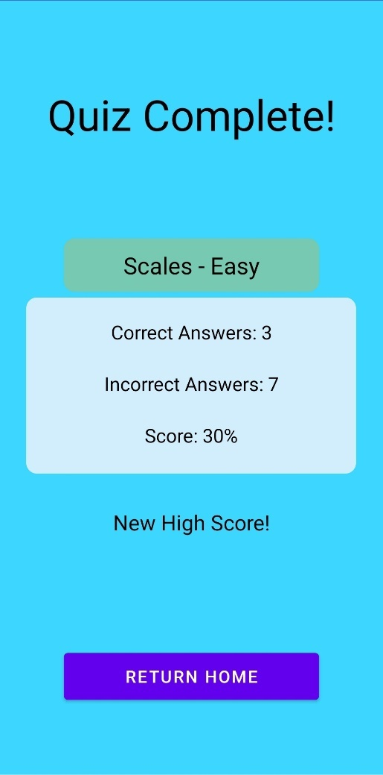Screen 11: Quiz Results

Here you will be shown the results of your quiz. If you have scored higher than your current high score, some text will appear to let you know. Press the Return Home button to progress.

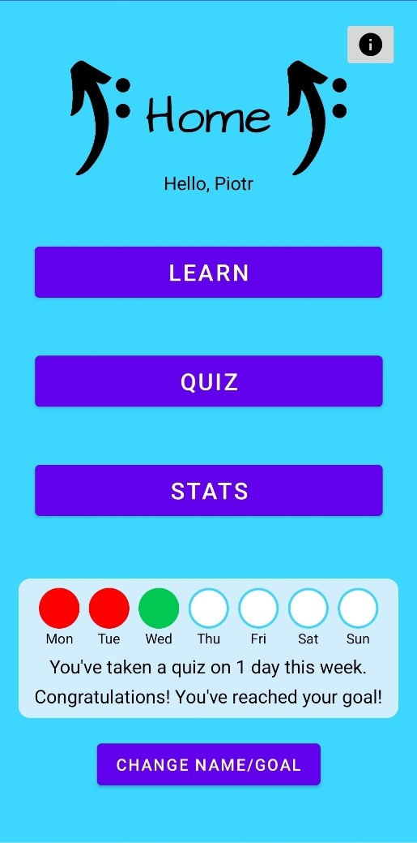Screen 12: Home (Updated)

Since you have completed a quiz, the circle for today will now be green, and progress towards your weekly goal will be updated. Press the Stats button to progress.

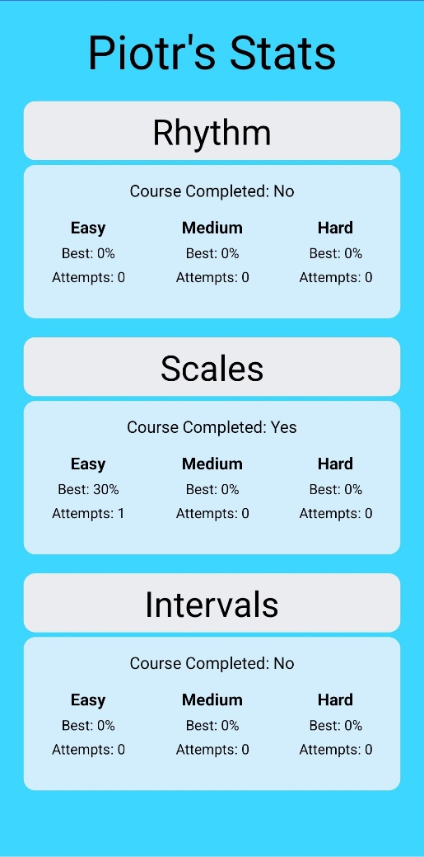Screen 13: Stats

Now that you have completed some of the learning materials and a quiz, your stats will be updated. Revisit this page whenever you like to keep track of your overall progress. You can exit this page by pressing your device’s built-in back button.

Congratulations, you have now finished the guide on how to